

Working Paper 08/2

Ethnic group migration within Britain during 2000-01:
a district level analysis

John Stillwell and Serena Hussain

Version 1.0

June 2008

All rights reserved



School of Geography, University of Leeds,
Leeds LS2 9JT, United Kingdom
This Working Paper is an online publication and may be revised.

Our full contact details are:

Mail address:
School of Geography
University of Leeds
Leeds, LS2 9JT
United Kingdom
Fax: +44 (0) 113 343 3308

Email:
John Stillwell
j.c.h.stillwell@leeds.ac.uk

Serena Hussain
s.hussain@leeds.ac.uk

John Stillwell is the contact author

TABLE OF CONTENTS

 |  | Page
 | Acknowledgements | iv
 | Abstract | iv
 | List of Tables | v
 | List of Figures | vi
1 | Introduction | 1
2 | Data, districts and ethnic diversity | 3
3 | Migration propensities at the national level | 8
4 | Spatial patterns of ethnic migration at the district scale | 12
5 | Net migration patterns in London | 23
6 | Conclusions and further research | 28
 | References | 31

Acknowledgements

The research reported in this paper has been supported by an ESRC small research grant (Ref: RES-163-25-0028) commissioned under the Understanding Population Trends and Processes (UPTAP) programme. The authors are grateful to Tony Champion and Ludi Simpson for their comments on an earlier version of the paper.

Abstract

Using data from the 2001 Census Special Migration Statistics, this paper explores how migration volumes, propensities and patterns vary between ethnic groups at the local authority district level in Great Britain. Whilst ethnic minority populations show a marked urban-rural contrast, ethnic minority net migration across the country does not reflect the pattern of counterurbanisation shown by the white group. In those districts with non-white shares of population above the national norm, there is evidence of higher white internal net out-migration. However, when we decompose the net migration balances of London’s boroughs, different spatial processes occurring in inner and outer boroughs are revealed and ethnic minority groups are shown to be decentralising from centres of concentration.

Keywords: migration; ethnic groups; census; migration propensity differentials; spatial net migration patterns.
List of Tables

Table |  | Page
Table 1: | Ethnic groups defined in the 2001 Census | 3
Table 2: | Ethnic population of Britain in 2001 | 5
Table 3: | Distribution of ethnic group populations by type of district, 2001 | 6
Table 4: | Internal migration in Britain by ethnic group, 2000-01 | 9
Table 5: | Summation of net migration flows for ethnic groups in each district category, 2000-01 | 16
Table 6: | Number of districts with net migration gains or losses by ethnic group, 2000-01 | 17
Table 7: | Correlation between population share and immigration by ethnic group | 22
Table 8: | Correlation between white and non-white net migration rates, London boroughs, 2000-01 | 28

List of Figures

Figure |  | Page
Figure 1: | The local authority districts in Britain, 2001 | 5
Figure 2: | Age structure of ethnic group populations, England and Wales, 2001 | 8
Figure 3: | Proportions of migrants within and between districts, by ethnic group, 2000-01 | 10
Figure 4: | Rates of migration within and between districts by ethnic group, 2000-01 | 10
Figure 5: | Migration in Britain by ethnic group and age, 2000-01 | 11
Figure 6: | Net migration balances for (a) total, (b) white and (c) non-white migrants, 2000-01 | 13
Figure 7: | District net migration balances for ethnic minority groups, 2000-01 | 14
Figure 8: | District out-migration and in-migration rate relationships, 2000-01 | 18
Figure 9: | Migration effectiveness by ethnic group, Britain, 2000-01 | 18
Figure 10: | White population share, 2001, and white net migration rate, 2000-01 | 19
Figure 11: | Non-white population share, 2001, and non-white net migration rate, 2000-01 | 20
Figure 12: | Non-white population share, 2001, and non-white immigration rate, 2000- 01 | 21
Figure 13: | Non-white population share, 2001, and number of non-white immigrants, 2000-01 | 21
Figure 14: | Non-white immigration rate and white net migration rate, 2000-01 | 22
Figure 15: | The ethnic complexion of London’s boroughs, 2001 | 24
Figure 16: | White net migration balances for London boroughs, 2000-01 | 25
Figure 17: | Relationship between net migration rates for London boroughs | 25
Figure 18: | Net migration balances for South Asian groups, London boroughs, 2000-01 | 26
Figure 19: | Net migration balances for Chinese, London boroughs, 2000-01 | 26
Figure 20: | Net migration balances for blacks, London boroughs, 2000-01 | 27
Figure 21: | Net migration balances for mixed and other groups, London boroughs, 2000-01 | 28

1 Introduction

Migration intensities are known to fluctuate with stage in life course (Rogers and Castro, 1981; Warnes, 1992; Champion et al., 1998). In comparison with age, sex is much less differentiating in its influence on migration whilst the role of socio-economic characteristics may vary as economic conditions change over time. It has also been shown that internal migration propensities vary by ethnic group (Robinson, 1992; Champion, 2005a) and that migration age profiles also vary between ethnic groups (Finney and Simpson, 2008; Hussain and Stillwell, 2008). In this paper we further examine the ethnic dimension and explore the spatial patterns of net migration at the district scale across Great Britain before concentrating attention on London and the processes revealed when net migration is decomposed into flows between boroughs within Greater London and flows between boroughs and districts in the rest of Britain.

In contrast to the popular press coverage that has highlighted international immigration in years since the last census and ethnic complexion in years to come, this paper is about internal migration taking place in the 12 month period before the 2001 Census. In fact, relatively little attention has been paid to internal migration in the Britain in the twenty-first century despite its importance as the key phenomenon responsible for explaining population change and demographic restructuring in many parts of the country; even less quantitative research on migration by ethnic group has been reported. The 1991 Census, together with other data sources like the National Health Service Central Register (NHSCR), have provided data that allows insights into migration patterns and processes in the 1990s (e.g. Champion, 2005b) but there have been relatively few studies that have focused specifically on ethnic groups (e.g. Robinson, 1992, 1993; Owen and Green, 1992; Champion, 1996). Similarly, since 2001, studies of ethnic migration have been much less popular than studies of ethnic population distributions more broadly and of segregation in particular. Champion (2005a) reviewed migration propensities at the national level and Large and Ghosh (2006) developed a cohort component methodology to estimate local authority district populations in England by ethnic group, constrained to the ONS mid-year population estimates. Stillwell and Duke-Williams (2003) have begun to explore linkage between ethnic populations, immigration and internal migration at this spatial scale whilst Simpson (2004) has used migration data to argue that certain ethnic groups are dispersing from concentrations of ethnic populations. More recently, Finney and Simpson (2008) have provided an overview of ethnic migration patterns and an explanation of the differences in distance migrated between certain groups.

The categorisation of ethnic groups in general terms is not straightforward. In addition to those white people born in this country to British parents, the so-called white-British majority, the population of Britain is composed of a diverse range of individuals whose ethnic group definition has been identified as part of a census classification for statistical purposes which expanded from eight categories in 1991 to double that in 2001 and will be extended further in 2011 if current proposals are accepted. Problems of linking census definitions of ethnicity with identity have been raised by Rankin and Bhopal (1999). Alternative methods of ascribing ethnicity to individuals based on personal names have been investigated by Mateos (2007), whose classification of population registers and small areas into cultural, ethnic and linguistic groups on the basis of names is one of the most sophisticated approaches yet developed. As we shall see in Section 2, a broad ethnic classification is used in this paper as the framework for examining the internal migration flows of ethnic minority groups whose members may have arrived in this country at some point in the past as immigrants from overseas or who are the second or third generation descendents of earlier immigrants.

Inevitably the spatial patterns of ethnic minority migration in 2000-01 examined in this paper were influenced by the extant geographical distributions of non-white populations across Britain which, as we also show in Section 2, are characterised by concentration in Greater London and in certain provincial towns and cities. However, we demonstrate how migration propensities vary between ethnic groups at the national level in Section 3 before the spatial patterns of net migration are examined and selected relationships between in-migration, out-migration, net migration, immigration and ethnic population share are investigated in Section 4. Thereafter, we focus on the London as the hub of the national migration system in Section 5, exposing the different migration processes that are occurring when we compute net migration using different systems of interest. Some conclusions and suggestions for further research are contained in Section 6.
2 Data, districts and ethnic diversity
The 2001 Census is the most reliable and comprehensive source of detailed data on migration flows within Britain at district, sub-district and small area scales, despite the fact that it becomes increasingly out of date as time passes. It provides transition data – flows of those in existence on census date who were also in existence 12 months previously but recorded at another usual address (Rees et al., 2002). The data that we use in this paper are for ethnic groups defined by the Office of National Statistics (ONS) and used to categorise migration flows at level 1 (district) in the Special Migration Statistics (SMS Table MG103). The SMS are produced for seven ethnic groups that are defined as aggregations of the 16 groups used in the Key Statistics (Table 1).

Table 1: Ethnic groups defined in the 2001 Census

Ethnic group defined in Special Migration Statistics (Level 1) | Ethnic group defined in Key Statistics
White | White British; White Irish; Other white
Indian | Indian
Pakistani and other South Asian | Pakistani; Bangladeshi; Other Asian
Chinese | Chinese
Caribbean, African, Black British and Black Other | Caribbean; African; Other black
Mixed | White and black Caribbean; White and black African; White and Asian; Other mixed
Other | Other

There is a fundamental distinction in the ethnic group classification based on skin colour between a single white group and six non-white groups which means that the internal migrants in the SMS who are British-born and white are not distinguishable from those white migrants within the UK who were born in Ireland or elsewhere in the world. Similarly, although Indians are distinguished from other South Asians, Pakistanis and Bangladeshis are lumped together with other South Asians into a single group, and black Caribbean, black African and other black migrants are aggregated into another single group. In contrast to the 1991 Census where no allowance was made for people of mixed ethnicity, there is a single mixed migrant group in 2001 in the SMS which is comprised on four mixed ethnic categories used in the main census tables: white and black Caribbean, white and black African, white and Asian and other mixed. This set of ethnic groups is not preserved below the local authority district scale in the SMS for Great Britain. At ward level, there is only a basic white/non-white distinction, and at output area level, there is no disaggregation by ethnic group whatsoever.

The data counts were extracted from SMS Table 3 using the Web-based Interface to Census Interaction Data (WICID) (Stillwell and Duke-Williams, 2003; Stillwell, 2006) for migration flows between local authority districts in England and Wales including 33 London boroughs, 36 metropolitan districts, 68 unitary authorities and 239 other local authorities, as well as flows for 32 Scottish council areas. The spatial system of 408 spatial units in Great Britain is shown in Figure 1, with different shading used to indicate different types of local authority. Northern Ireland has been excluded from the analysis because there are no equivalent SMS data by ethnic group in SMS Table MG103; in fact the data for Northern Ireland are contained in Table MG103n and have been produced for parliamentary constituencies rather than local authority areas, presenting additional difficulties in obtaining accurate populations at risk (see Dennett and Stillwell, 2008). The data between districts in England and Wales and into districts from Scotland have been subject to the small cell adjustment method (SCAM) by ONS whereas the flows between council areas in Scotland and into these area from England and Wales have not been adjusted. It is unlikely that the effect of the adjustment will be significant at this spatial scale because of the relatively large size of the spatial units and the comparatively broad ethnic group categories. SCAM has had more profound impact for smaller spatial units such as output areas (Stillwell and Duke-Williams, 2006).

The ethnic dimension of Britain’s population has been studied by various researchers at national (Ratcliffe, 1996; Peach, 1996a; Phillips, 1998, 2006; Scott et al., 2001; Rees and Butt, 2004; Lupton and Power, 2004; Simpson, 2004, Johnson et al., 2006) and local levels (Rees et al., 1995; Peach, 1996b; Peloe and Rees, 1999; Johnson et al., 2001; Simpson, 2005; Stillwell and Phillips, 2007) using data from the 1991 and 2001 censuses. It is clear from the Key Statistics summarized in Table 2 that the non-white component is responsible for just over 8% of the 57.1 million people living in Britain in 2001. Largest amongst the non-white groups is the Pakistani and Other South Asian (POSA) population which, together with the Indians, represents over 2.3 million individuals or half of the non-white population. The South Asian population is double that of the black population with the mixed group now accounting for 1.2% of the total population and the Chinese and other non-white groups both having similar numbers and accounting for 0.4% of the total population respectively.

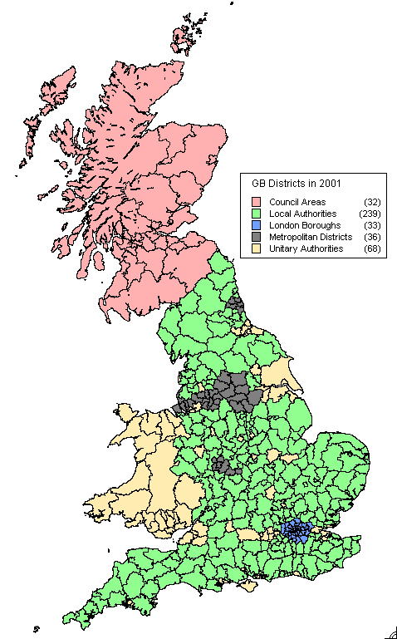

Figure 1: The local authority districts in Britain, 2001

Table 2: Ethnic population of Britain in 2001

Ethnic group | Population | Percentage | Index of segregation
White | 52,481,200 | 91.9 | 0.5275
Indian | 1,051,844 | 1.8 | 0.5742
POSA | 1,276,892 | 2.2 | 0.5577
Chinese | 243,258 | 0.4 | 0.3198
Black | 1,147,597 | 2.0 | 0.6526
Mixed | 673,796 | 1.2 | 0.3354
Other | 229,324 | 0.4 | 0.4354
Source: Key Statistics, 2001
Various of the previous studies mentioned above have shown the geographical concentration of ethnic minorities in London and certain provincial cities although the spatial distributions across the country do vary between groups. Table 2 shows index of segregation (IOS) scores for ethnic groups computed at district level as:

IOS = 0.5 ∑|P_{ie}/P_{*e}- P_{ir}/P_{*r}| (1)

where P_{ie} is the population of ethnic group e in zone i;
P_{*e} is the population in ethnic group e in Britain;
P_{ir} is the rest of the population in district i; and
P_{*r} is the rest of the population in Britain.

The IOS scores show that the black population was the most segregated in 2001 rather than either of the South Asian populations, whereas the least segregated group was the Chinese. The index score for whites appears relatively high because the rest of the population used in equation (1) is the total non-white population of each district. Table 3 presents a summary of the geographical variation of each ethnic population according to the proportions resident in each type of district. Over two thirds of the black population live in London boroughs compared with one third of the POSA, Chinese and the mixed groups. Nearly half the other non-white ethnic group and over two fifths of Indians live in London in comparison with less than one tenth of the white population.

Table 3: Distribution of ethnic group populations by type of district, 2001

Ethnic group | London boroughs  % | Metropolitan  districts  % | Unitary authorities and council areas  % | Other local authorities  %
White | 9.7 | 18.5 | 29.3 | 42.4
Indian | 41.5 | 23.8 | 19.3 | 15.3
Pakistani & OSA | 33.7 | 36.9 | 17.2 | 12.2
Chinese | 33.0 | 17.8 | 22.1 | 27.1
Black | 68.2 | 14.4 | 9.0 | 8.3
Mixed | 33.6 | 21.4 | 18.7 | 26.3
Other | 49.3 | 13.0 | 16.6 | 21.1
Source: Authors’ calculations based on 2001 Key Statistics

These figures emphasize the importance of the capital city as the hub of ethnic minority group location, although in the case of the POSA population, a higher proportion live in provincial metropolitan districts than in London. From a spatial analytical perspective, current debate surrounds whether geographical segregation of ethnic minority populations in Britain is increasing and how the processes of natural change and internal migration and immigration interact to create communities that are ethnically more or less diverse. This debate has been very contentious in the USA where evidence has been presented of ‘demographic balkanisation’ across broad regions involving “spatial segmentation of population by race-ethnicity, class, and age across broad regions, states, and metropolitan areas… driven by both immigration and long distance internal migration patterns” (Frey, 1996: 760) and resulting in what has been termed ‘white flight’ with the arrival of non-white immigrants ‘pushing’ out white residents. Yet Ellis and Wright (1998) condemn Frey on racial grounds and believe that white counterurbanisation is happening anyway, creating vacancies or opportunities that ‘pull’ non-white immigrants into cities.
Despite the fact that the situation in the USA is magnified because of the size of the ethnic groups involved, it has led researchers to ask whether similar processes are occurring in Britain and whether there is any evidence of ethnic ghettoes emerging in British cities (Peach, 1996b; Johnston et al., 2002). The evidence tends to be to the contrary. Simpson (2005) has compared the ethnic structure of electoral wards in England and Wales in 1991 and 2001 and found that there has been only a relatively small increase in the number of mixed wards – where 10% or more residents are from an ethnic minority – suggesting that claims of increasing ghettoization are ill-founded. Simpson argues that the census counts show that non-white residents are leaving inner cities rather than moving to them. Nevertheless, it is clear from comparing the age structures of ethnic minority populations (Figure 2) at the national level that processes are taking place that involve in situ growth through natural change. The share of each ethnic group population in the 0-15 age range is significantly higher for the South Asian and black minority populations than it is for whites, and over 50% of the mixed ethnic group population are aged under 16. At ages 16-19, 20-24 and 25-29, the percentage of shares of the total white population are lower than any of the ethnic minority groups, whereas much larger shares of the white population are found in older age groups. All the ethnic minority groups therefore have younger populations than the majority white population.
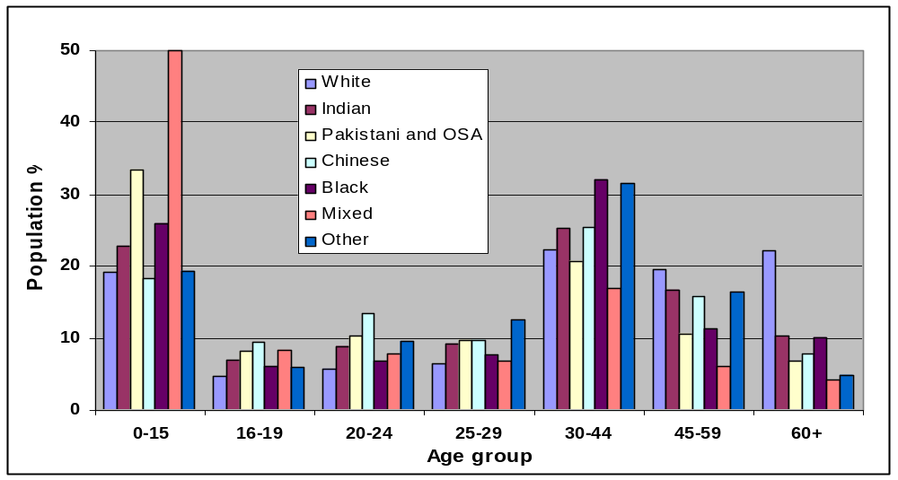
Source: Authors’ calculations from 2001 Census data via CASWEB

Figure 2: Age structure of ethnic group populations, England and Wales, 2001

These demographic structures, together with ethnic minority immigration focused on areas where ethnic minorities are already located (Stillwell and Duke-Williams, 2005) implies further concentration but begs questions as to whether these components of population growth are being counterbalanced or offset by net outward movement of ethnic minority populations from centres of concentration, as Simpson suggests, or whether the ethnic complexion of different areas is being influenced more by the migration patterns of the white population. In this paper, we to look in more detail at the patterns of ethnic internal migration.

3 Migration propensities at the national level
A search of recent literature on migration in Britain (Dennett and Stillwell, 2008) has indicated that whilst there are many studies of internal migration in the second half of the twentieth century, relatively little research has been undertaken using migration data from the 2001 Census and even less attention has been paid to the ethnic dimension of migration. Champion (2005a) shows whites having marginally lower migration tendencies than non-whites in the UK in the 12-month period before April 2000 (and very different net migration patterns); Bailey and Livingston (2005) use Samples of Anonymised Records (SARs) data to establish migration rates for five ethnic groups in Britain as a whole; whilst the Greater London Council Data Management and Analysis Group has produced a detailed briefing on ethnic migration in London (Mackintosh, 2005). In Table 4, we present the variations in migration flows between ethnic groups, disaggregating the total of over 6 million flows into those between and those within districts. As expected, the large majority of migrants are white, with the ethnic minority population contributing 9% of the total. The migration percentages are in line with the population shares.

Table 4: Internal migration in Britain by ethnic group, 2000-01

Ethnic group | Inter-district migrants |  | Intra-district migrants |  | Total migrants
Ethnic group | Number | % | Number | % | Number | %
White | 2,215,010 | 90.4 | 3,295,652 | 91.4 | 5,510,662 | 91.0
Indian | 50,997 | 2.1 | 52,460 | 1.5 | 103,457 | 1.7
POSA | 44,567 | 1.8 | 87,051 | 2.4 | 131,618 | 2.2
Chinese | 19,476 | 0.8 | 16,317 | 0.5 | 35,793 | 0.6
Black | 61,748 | 2.5 | 78,063 | 2.2 | 139,811 | 2.3
Mixed | 40,930 | 1.7 | 56,519 | 1.6 | 97,449 | 1.6
Other | 17,498 | 0.7 | 18,380 | 0.5 | 35,878 | 0.6
Total | 2,450,226 | 100.0 | 3,604,442 | 100.0 | 6,054,668 | 100.0
Source: SMS Table MG103

The variation in the inter/intra district proportions of flows by ethnic group are shown graphically in Figure 3. In total and for the white migrant population, there is a ratio of 40:60 between inter and intra-district flows but the ratio is close to 50:50 for Indians and the Chinese are the only minority group to show a higher propensity to move between rather than within districts. The Chinese are well-known to have a rather disparate distribution due partly to their role in service provision in the catering industry. It is the POSA group that records the lowest proportion of inter-district migrants and therefore the highest proportion of intra-district flows. More detailed analysis of the distance of migration based on SARs data is reported in Finney and Simpson (2008) who suggest that the higher proportion of shorter distance moves for certain minority groups may reflect the more densely populated urban environments which they inhabit. London is a prime example of people living closer together and moving shorter distances to new neighbourhoods which may not involve crossing borough boundaries.
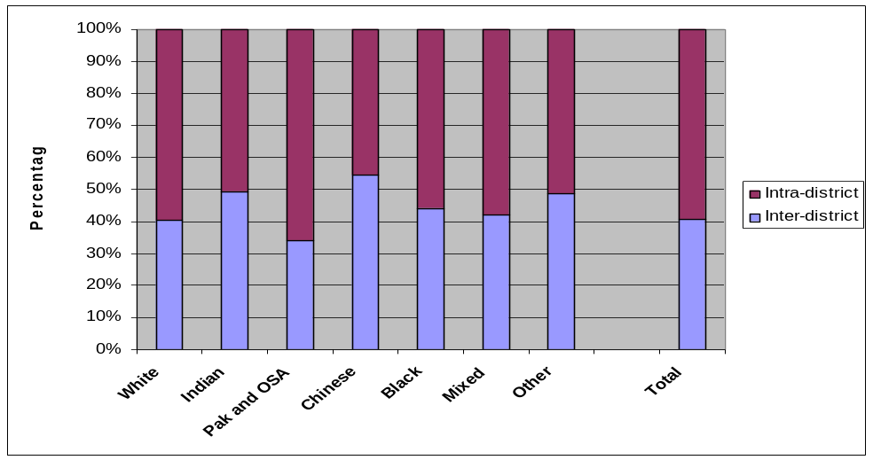

Figure 3: Proportions of migrants within and between districts, by ethnic group, 2000-01

When ethnic group migration rates are computed using the 2001 Census populations at risk as the denominators (Figure 4), it is evident that the aggregate Chinese propensity to migrate is only exceeded by the rate for the other non-white ethnic group, although the Chinese have the highest rate of inter-district migration at 8% of their population. The rate of inter-district migration for the POSA group, however, is less than half the rate experienced by the Chinese despite having very similar rates of intra-district migration.
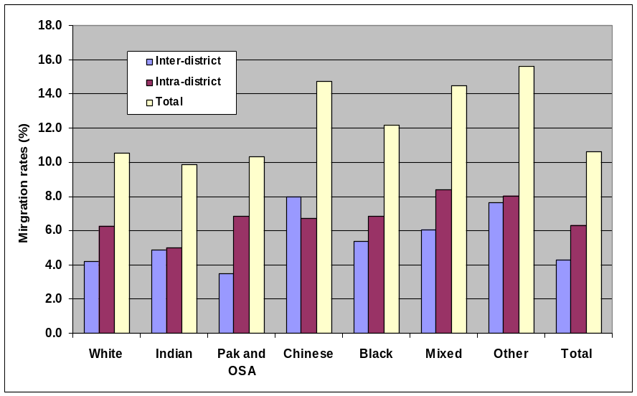

Figure 4: Rates of migration within and between districts by ethnic group, 2000-01

This classification indicates that it is the Indian population that has the lowest rate of intra-district migration and the lowest overall migration propensity but Finney and Simpson (2008) use a more disaggregated ethnic group breakdown based on data commissioned from ONS which shows the black Caribbean group as having a migration intensity of 10.8%. Can we gain insights into these variations by considering male and female propensities and age-specific rates of migration?

The difference in migration propensity between males and females is relatively insignificant compared with age-group differentials, but it is interesting to note that more females migrate than males in each ethnic group in Britain with the exception of those in the POSA group. Overall, there are 97 white male migrants for every 100 white female migrants compared with 114 POSA male migrants for every 100 females. In terms of age, Figure 5 shows two percentage stacked column graphs. The top graph demonstrates how the white share of total migration increases linearly through the age groups; at age 0-15, 88% of migration is white whereas at age 60+, over 96% is white. The lower graph summarizes the shares age-specific shares migration in each ethnic group; the most significant variations are shown by the Chinese whose migrants aged 20-24 account for a significant share (32%) of the total Chinese migration, and migrants of mixed ethnicity of which 41% are children aged 0-15.

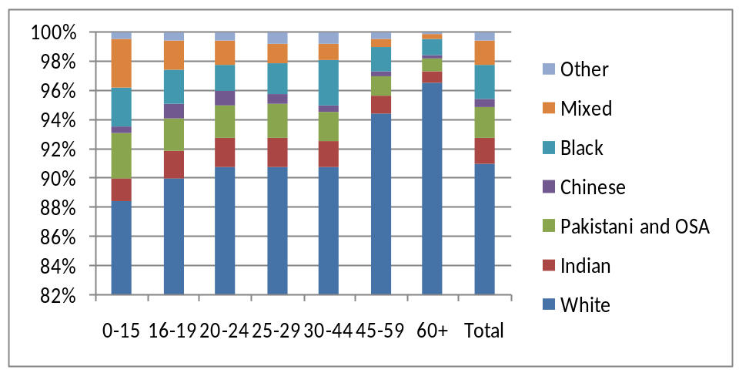
(a) By age and ethnic group
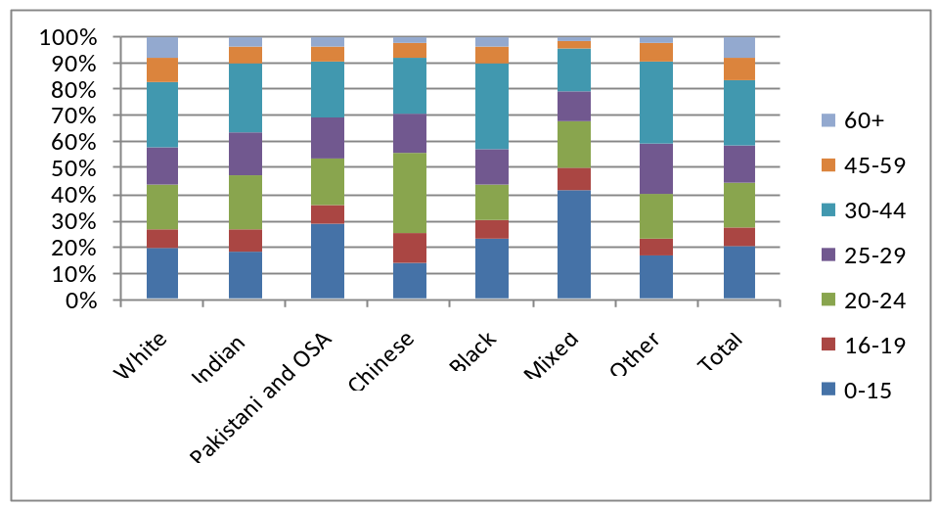
(b) By ethnic group and age

Source: 2001 Census commissioned table

Figure 5: Migration in Britain by ethnic group and age, 2000-01

Hussain and Stillwell (2008) have computed age-specific migration rates by ethnic group for all migrants in England and Wales in 2000-01 which show that at the peak age of migration (20-24), rates for both the South Asian groups are significantly lower than for other groups. Part of the explanation for the low migration propensities of young South Asians stems from their cultural norms of leaving home at a later age than other ethnic groups, accentuated by their choice to live at home whilst studying in higher education. Finney and Simpson (2008) provide a portrait of ethnic migration at the national level which includes distance moved, tenure, qualification, illness and economic activity variables, using multiple regression methods to confirm the importance of age and socio-economic composition as explaining rate variations between ethnic groups. In the remainder of this paper which considers spatial patterns of net migration, we concentrate on all-age migration flows and rates.

4 Spatial patterns of ethnic migration at the district scale

Geographical patterns of net migration in Britain arise as a result of the combination of complex processes involving the redistribution of different segments of the population with different sets of motivations for migration. These processes, which include decentralisation or deconcentration on the one hand, may be counterbalanced by centralisation or concentration on the other. Moreover, the processes may be taking place at different spatial scales; counterurbanisation, for example, is likely to occur over longer distances than suburbanisation, whereas processes like gentrification and residualisation tend to occur at an intra-urban scale. The movement of students is one of the important sub-categories of migration taking place in Britain at the district scale and Champion (2005a) points out that districts with the highest numbers of inflows tend to be those with the highest student populations. However, the spatial pattern of aggregate net migration at the district scale in 2000-01 remains distinctly similar to that in 1990-91 (Stillwell and Duke-Williams, 2006). Figure 6a shows the pervasive counterurbanisation pattern of net migration losses from metropolitan areas and gains in rural areas that has been recognised by Champion (2005a) using a classification of districts adapted from work carried out in the early 1980s and by Dennett and Stillwell (2008) using the Vickers et al. (2003) classification of districts in 2001. Figure 6b shows that the net migration balances at district level for whites determines the pattern of total balances, whilst the distribution of net balances for non-whites (Figure 6c) is confined to a relatively small number of metropolitan areas either gaining or losing through net migration.

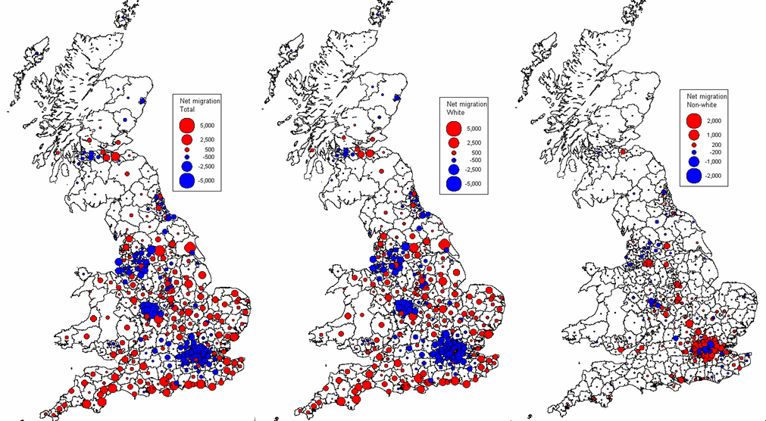
(a) Total (b) White (c) Non-white

Source: 2001 Census SMS

Figure 6: Net migration balances for (a) total, (b) white and (c) non-white migrants, 2000-01

The net migration balances of non-whites presented in Figure 6b are disaggregated into ethnic minority group net migration patterns in Figure 7 where a standardised shading scale has been used to allow comparisons to be made. The two South Asian net migration maps show different patterns of losses and gains in northern and midland towns and cities as well as different patterns in London, whereas the Chinese net flows are much smaller in magnitude and more diffuse in extent. The pattern of black migration is dominated by gains in districts in the south of the country as well as in midland cities although there are losses in certain London boroughs. The magnitudes of net balances are much smaller for the last two groups, and the patterns vary between them with some interesting gains along the south coast and around the Severn estuary for the mixed group.

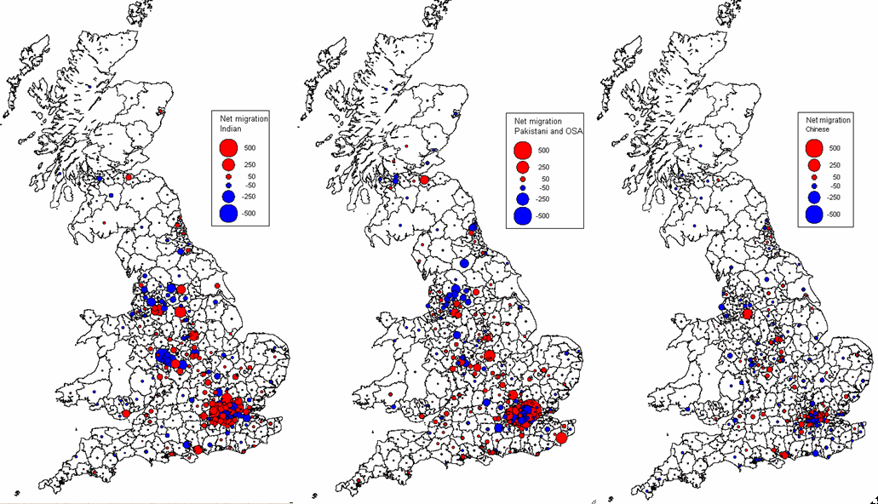
(a) Indian (b) POSA (c) Chinese

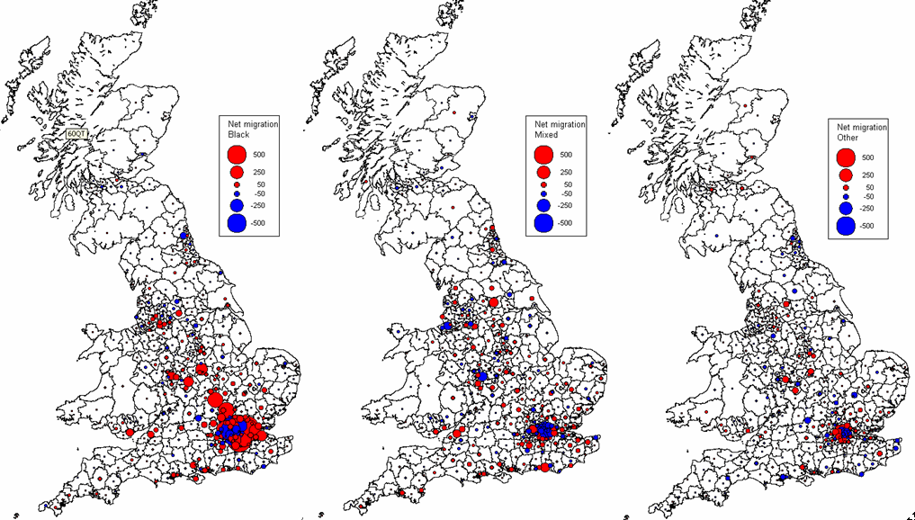

(d) Black (e) Mixed (f) Other

Source: 2001 Census SMS

Figure 7: District net migration balances for ethnic minority groups, 2000-01

The detailed district-level maps in Figures 6 and 7 are valuable as a means of visualising concentrations of net migration loss or gain but a lack of precision and clarity indicates why it is necessary to summarize the patterns for the whole country using national district classifications and to look separately at the patterns in London. Hussain and Stillwell (2008) provide an analysis of these data disaggregated by age using the Vickers et al. (2003) classification of districts into families and classes whilst London is examined in more detail in Section 5. Here we present two summaries: firstly, the sum of the net migration balances for ethnic groups (Table 5) in each of the categories of district identified in Figure 1; and secondly, the number of districts with net gains or losses in each category (Table 6). The first of these summaries demonstrates an almost mirror image of the pattern of net loses and gains between the categories. London boroughs are losing around 50,000 migrants in 2000-01 whereas other local authorities (rural England) are gaining a similar number; metropolitan districts are losing around 20,000 migrants whereas unitary authorities and council areas in Scotland are collectively gaining a similar number in net terms. However, we must remember that Table 5 shows us statistics resulting from adding the net balances for each district in each category; not the overall net flows between these categories if we were to aggregate the districts into each category together and therefore remove flows between districts within categories.

Table 5: Summation of net migration flows for ethnic groups in each district category, 2000-01

Ethnic group | London boroughs | Metropolitan districts | Unitary authorities | Other local authorities | Council  areas
 | Net flow | Net flow | Net flow | Net flow | Net flow
White | -43,918 | -19,880 | 17,459 | 45,761 | 578
Indian | -885 | -696 | 478 | 1,169 | -66
POSA | -1,525 | 125 | 835 | 602 | -37
Chinese | 353 | 57 | 51 | -394 | -67
Black | -4,456 | 452 | 2,260 | 1,800 | -56
Mixed | -2,071 | 71 | 499 | 1,560 | -59
Other | 118 | 19 | 242 | -419 | 40
Total | -52,384 | -19,852 | 21,824 | 50,079 | 333
Source: SMS Table MG103

Whilst the total net balances are dominated by whites in absolute terms, the net exchanges for different types of district vary by ethnic group. Net balances for Indians have similar signs to white flows except for Scottish council areas where they show small net losses like all the other minority groups apart from other. Amongst the remaining groups, Blacks show the largest absolute losses from London boroughs and the largest gains in both unitary authorities and other local authorities; all groups show gains in provincial metropolitan England and unitary authorities; the Chinese and other groups show loses from other local authorities.

The numbers of districts experiencing net gains and losses of white migrants summarise the pattern of counterurbanisation apparent in Figure 6; only 12 out of 69 London boroughs and metropolitan districts experienced gains whilst 63% of unitary authorities and 61% of other local authorities in England and Wales had positive balances. In Scotland, however, more council areas were losing population by net migration than gaining across all ethnic groups. In London, the patterns of borough gains and losses is much less consistent, with the Indian, Chinese and other groups showing more net gains than losses, whilst in the provincial metropolitan districts, it is the POSA, black and mixed groups that have a majority of gains. More unitary authorities gain than lose net migrants in each ethnic group apart from the Chinese who also have more losses than gains for other local authorities. However, in this latter district category, both the Indian and other ethnic groups also have more losses than gains.

Table 6: Number of districts with net migration gains or losses by ethnic group, 2000-01

Ethnic group | London boroughs |  | Metropolitan districts |  | Unitary authorities |  | Other local authorities |  | Council  areas
 | Gain | Loss | Gain | Loss | Gain | Loss | Gain | Loss | Gain | Loss
White | 4 | 29 | 8 | 28 | 43 | 25 | 146 | 93 | 13 | 19
Indian | 17 | 16 | 13 | 22 | 33 | 31 | 110 | 114 | 12 | 17
POSA | 12 | 21 | 20 | 16 | 40 | 23 | 134 | 92 | 12 | 20
Chinese | 20 | 13 | 17 | 17 | 32 | 33 | 100 | 121 | 13 | 15
Black | 15 | 18 | 22 | 14 | 47 | 17 | 129 | 97 | 14 | 18
Mixed | 8 | 25 | 19 | 15 | 36 | 30 | 143 | 90 | 14 | 17
Other | 20 | 11 | 17 | 18 | 34 | 30 | 94 | 114 | 14 | 17
Total | 3 | 30 | 8 | 28 | 42 | 26 | 151 | 88 | 11 | 21
Note: The number of gains and losses by ethnic group in each category will not necessarily sum to the same total because of zero net migration balances Source: SMS Table MG103

Another measure for comparing migration patterns between ethnic groups involves the relationship between migration rates. It has long been understood that gross out-migration rates tend to have a strong correlation with gross in-migration rates (Cordey-Hayes and Gleave, 1975; Rogers, 1978). Areas of growth and prosperity tend to have high rates of in-migration and out-migration whereas those of decline or stagnation have low rates. Migrants move to districts which have higher intrinsic attractiveness (more jobs, housing opportunities, better environment) in the first instance but, because new migrants have a higher propensity to migrate than those who have been resident for longer due to the influence of cumulative inertia, out-migration is also more likely. This rate relationship is certainly apparent for white inter-district migrants (Figure 8a) with a correlation coefficient of 0.932 but much less so for non-whites (Figure 8b) where the coefficient falls to 0.415 and summarizes a range of relationships for individual groups that are much lower, ranging from 0.285 for the POSA group down to 0.021 for the other ethnic group.
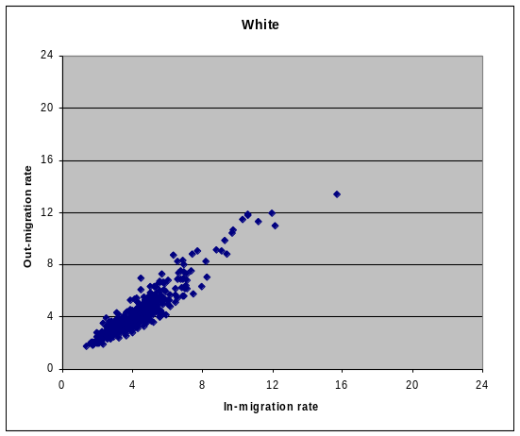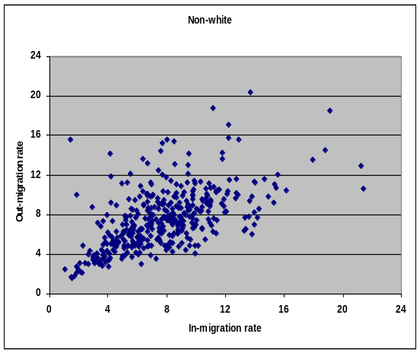
(a) White (b) Non-white

Figure 8: District out-migration and in-migration rate relationships, 2000-01

Thus, ethnic minority net migration gains and losses tend to be more significant relative to turnover than for whites, where in most cases rates of out-migration and in-migration cancel out. In other words, the effectiveness of net migration for ethnic minorities tends to be higher than for whites as demonstrated by the system-wide migration effectiveness (ME) indices shown in Figure 9. Compared with the 5% of white migrant turnover redistributed by net migration, the ME score of blacks is 18% and all the other minority groups have scores over double that of whites.
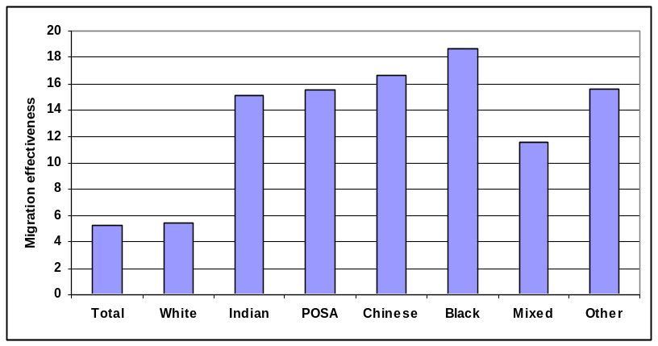
Migration effectiveness or efficiency is computed as 100(∑|D_{i}-O_{i}|/ ∑|D_{i}+O_{i}|)

Figure 9: Migration effectiveness by ethnic group, Britain, 2000-01

One important question is whether rates of white net migration bear any relationship with the ethnic composition of district populations. This question might be rephrased as to whether districts whose populations contain larger shares of non-whites are those that experience higher levels of white net migration loss; in other words, are whites leaving areas where non-whites predominate at a disproportionate rate. There is some evidence of this from Figure 10 where we have ranked each district on the basis of its white population share (from left to right) and plotted this ranking against the white net migration rates for the corresponding districts. The horizontal line represents zero net migration. To the right of the vertical line are the 74 districts whose white population shares are below the national figure of 91.9%. Despite significant variation in net migration rates between districts, there is a definite trend towards higher negative net migration balances with increasing shares of non-white residents. The two areas that are conspicuous in the upper right quadrant of the graph by having significantly high positive net migration balances are the London boroughs of City of London and Lambeth. The former has only a very small resident population and is the focus of the capital’s financial and business district, both factors affecting its migration rate balance. The latter is one of the inner London boroughs which has a large multiethnic population but still manages to attract white migrants in net terms. When the non-white percentage shares for districts are ranked in descending order and plotted against non-white net migration rates (Figure 11), the latter show less variation around zero than for white net migration rates, with least variation in the areas with the highest non-white population shares.
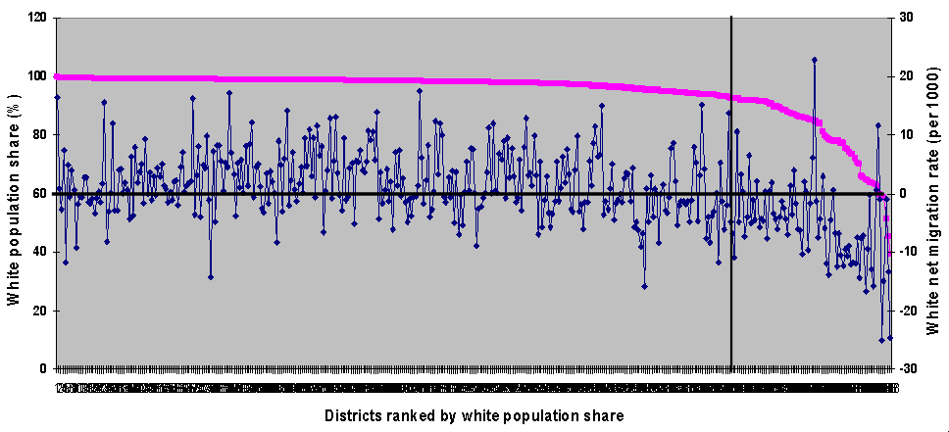

Figure 10: White population share, 2001, and white net migration rate, 2000-01

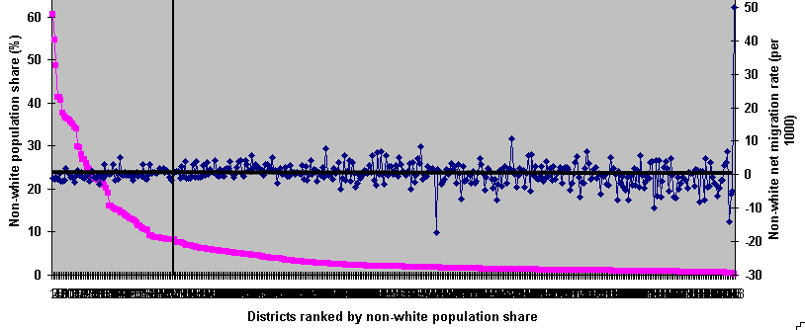

Figure 11: Non-white population share, 2001, and non-white net migration rate, 2000-01

This analysis does not allow us to draw conclusions about the processes that are influencing the changing population complexion of districts and the redistribution of their populations through migration but it does suggest that while there are districts experiencing net migration losses of whites that have very small non-white population shares, there are a number of districts, particularly in London but also elsewhere in urban Britain where net losses of white migrants increase as the white population share decreases. We should also consider the additional component of population change that occurs though international inflows and outflows. Since emigration flows are not captured by the census, we focus here on immigration rates and consider the relationship between non-white population share and non-white immigration by and between non-white immigration and white internal net migration.

In Figure 12, we aggregate the non-white groups together and plot the districts ranked on the basis of their non-white population share against their non-white immigration rates, calculated using non-white PAR as denominators. Contrary to expectation, the districts with the highest shares of non-whites in their populations are amongst those with the lowest immigration rates. However, the relationship between the percentage non-white is much stronger if the number of immigrants is the variable used rather than the non-white immigration rate (Figure 13). In other words, areas where there are high proportions of non-whites have more non-white immigrants but lower rates of immigration when compared to areas with lower percentage non-white shares.

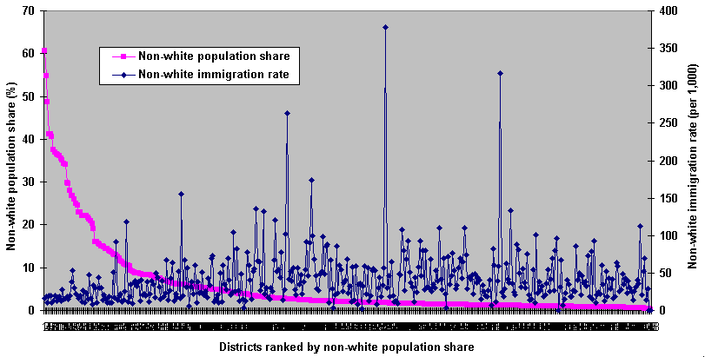

Figure 12: Non-white population share, 2001, and non-white immigration rate, 2000-01

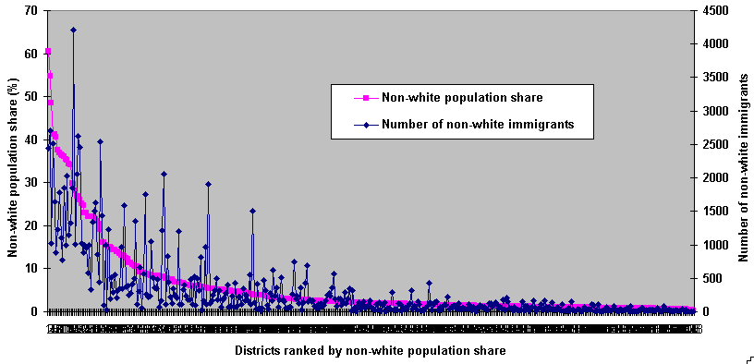

Figure 13: Non-white population share, 2001, and number of non-white immigrants, 2000-01
In Table 7, we present some correlation coefficients indicating the strength of the relationship between ethnic group population share and ethnic group immigration for each of the seven groups. The only significant coefficient for rates is that for the white group, indicating that as the percentage share of whites increases, the white immigration rate falls as do the numbers of white migrants; in other words, white immigrants are more attracted to areas where white population shares are lower and less attracted to areas with high white population shares. Correlation with immigration rates is insignificant for all the other ethnic groups but positive correlations are found with the number of immigrants in each group. The highest correlation is computed for the black group whereas Chinese immigrants have the lowest correlation.

Table 7: Correlation between population share and immigration by ethnic group

Ethnic group | r coefficient
Ethnic group | Immigration rate | Number of immigrants
White | -0.468 | -0.519
Indian | -0.145 | 0.804
POSA | -0.094 | 0.712
Chinese | 0.145 | 0.685
Black | -0.219 | 0.847
Mixed | 0.012 | 0.772
Other | -0.063 | 0.767

Finally, we consider the relationship between non-white immigration and white internal net migration. Figure 13 shows the plot of districts ranked by their non-white immigration rates from left to right, together with their corresponding white net migration rates. The graphs indicate higher rates of white net out-migration for those districts with higher rates of ethnic minority immigration, although there is considerable variation in net migration rates as immigration rates decline and the coefficient measuring correlation between the two data series is only -0.367.

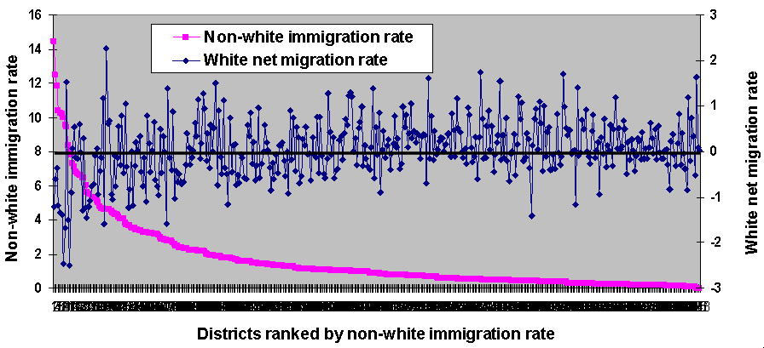

Figure 14: Non-white immigration rate and white net migration rate, 2000-01

This analysis emphasises the relatively concentrated nature of ethnic minority populations across Britain as a whole but does suggest that in those districts where the non-white population share is above the national share, non-white immigration numbers are higher though rates are lower and it is these districts that are experiencing the highest rates of population loss through net out-migration. The 74 districts whose white population is less than the national percentage include all 33 London boroughs except for Havering, and therefore in the next section of the paper, we explore the patterns of net internal migration by ethnic group in London in more detail.

- Net migration patterns in London
As well as hosting 45% of the country’s non-white usually resident population, London is the hub of the national internal migration system; it was also the destination for 35% of immigrants in 2000-01. In the boroughs of Newham and Brent, the majority of the population in 2001 was non-white and there were 16 other boroughs where the non-white population share was between 25% and 50% (choropleth shading in Figure 15), including major concentrations of blacks south of the river in Lambeth, Southwark, Lewisham and Croydon and north of the river in Newham, Hackney, Haringey and Brent. The proportional pie charts in Figure 15 also indicate particular concentrations of Indians in north west London, of Pakistani and OSAs in Newham, Tower Hamlets and Redbridge and of other non-white in Ealing and Barnet. More detailed analysis of ethnic group distributions and migration can be found in the briefings prepared by the Greater London Data Management and Analysis Group (e.g. Bains, 2005, Mactintosh, 2005).
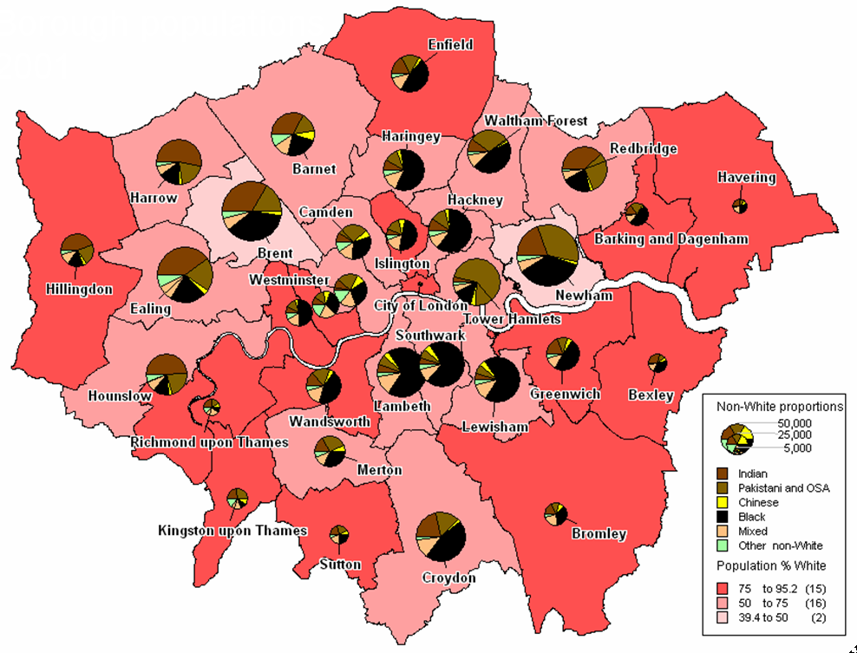

Figure 15: The ethnic complexion of London’s boroughs, 2001

In this section, we examine ethnic group net migration patterns in London, recognising that 30 of the boroughs experienced net migration losses in aggregate (Table 5) in 2000-01. Using net migration counts, we distinguish net flows taking place each borough and all other boroughs in London and net flows between each borough and the rest of GB (RoGB). The spatial patterns that emerge for whites (Figure 15) provide evidence of the centrifugal and decentralising processes occurring simultaneously. Within London, it is the inner London boroughs, particularly north of the river that lost net migrants and the outer London boroughs that gained. However, most of those inner London boroughs losing through shorter distance moves gained migrants in net terms through longer distance in-migration from the rest of the country. At the same time, the outer London boroughs lost migrants to the rest of the country. The negative relationship between the two sets of net migration rates is demonstrated in Figure 17.

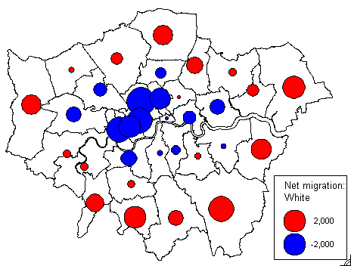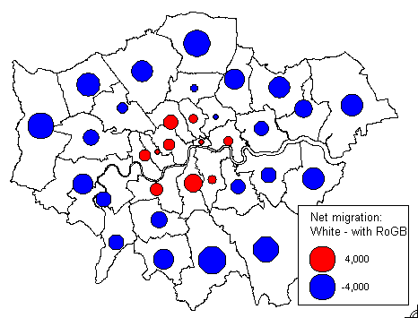
(a) White within London (b) White with the rest of GB

Figure 16: White net migration balances for London boroughs, 2000-01

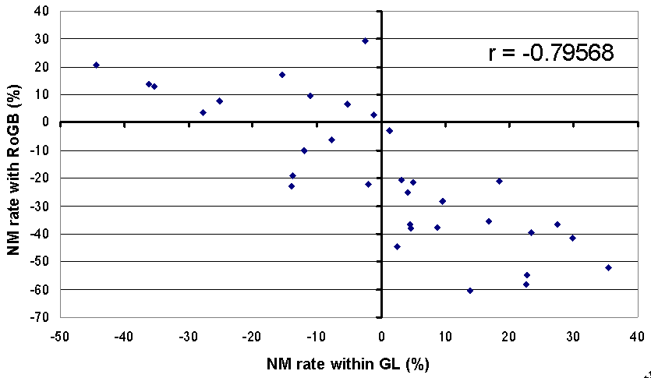

Figure 17: Relationship between net migration rates for London boroughs

To what extent do the patterns of ethnic migration for the non-white ethnic groups conform with the pattern shown in Figure 16 for whites? Are the same processes of spatial restructuring taking place? Figure 18 shows maps for the two South Asian groups. In the case of migration within London, both the Indian and the POSA groups suggest a decentralisation from areas of ethnic population concentration to the outer boroughs, although at least three of the inner boroughs have positive balances for Indians. Likewise, Inner London boroughs are gaining Indian migrants from the rest of Britain whilst the main losses of Indians are from the western boroughs of Harrow, Brent, Ealing, and Hounslow, all of which have large Indian populations. These areas also show high net losses of those in the POSA although the net exodus extends to other boroughs in the east and south.

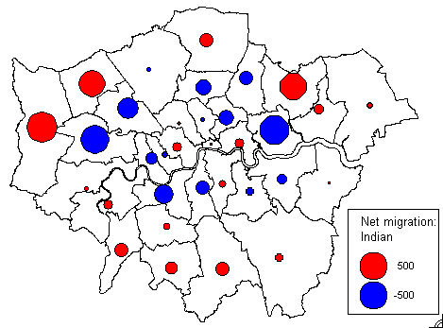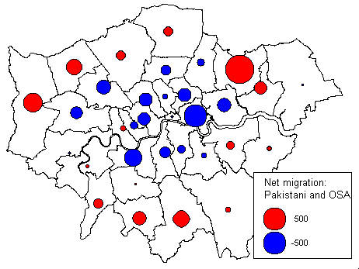
(a) Indian within London (b) Pakistani and OSA within London

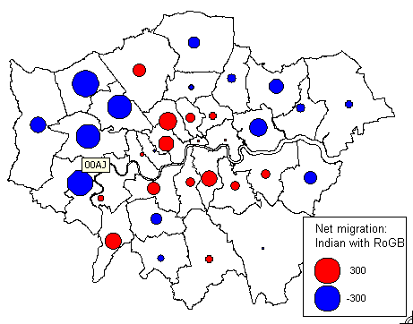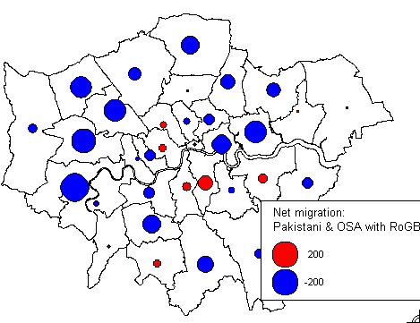
(c) Indian with rest of GB (d) Pakistani and OSA with rest of GB

Figure 18: Net migration balances for South Asian groups, London boroughs, 2000-01

The net migration balances are not particularly large in absolute terms and this particularly so for the Chinese (Figure 19), whose spatial pattern of migration within London is more confined to the inner boroughs that tend to lose to certain adjacent boroughs but gain from in-moves from the rest of the country.

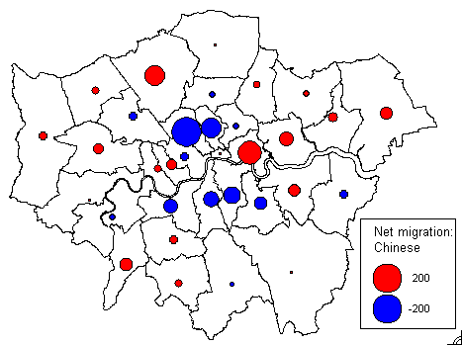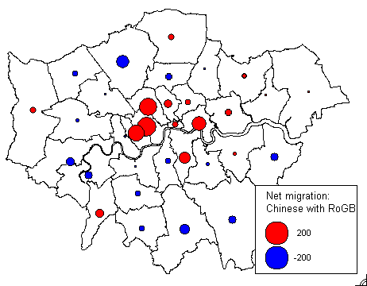
(a) Chinese within London (b) Chinese with rest of GB

Figure 19: Net migration balances for Chinese, London boroughs, 2000-01

The largest net migration balances are apparent for the black group (Figure 20) with the pattern of movement within London showing closer similarity to the white pattern than the South Asians or the Chinese. However, almost all the London boroughs show net losses with the rest of Britain – black migrants are leaving London in net terms, particularly from areas where their populations are more concentrated.
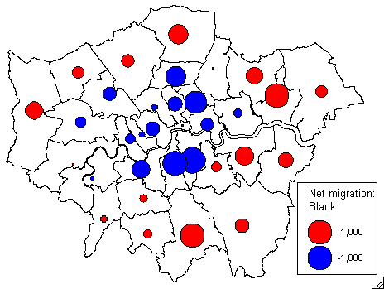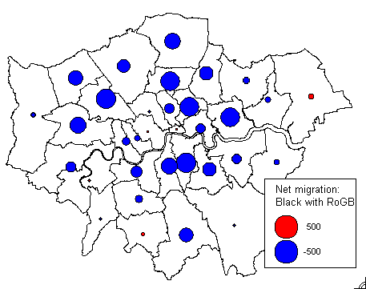
(a) Black within London (b) Black with rest of GB

Figure 20: Net migration balances for blacks, London boroughs, 2000-01

Finally, the patterns in intra-London net migration for the mixed and other groups show similarities with the white distribution although the proportional symbols show that net exchanges are smaller for the other group (Figure 21). On the other hand, the patterns of net migration with the rest of Britain are somewhat different – most boroughs are losing migrants of mixed ethnicity apart two in the centre, whereas west London is gaining migrants in the Other group whilst east London in losing.

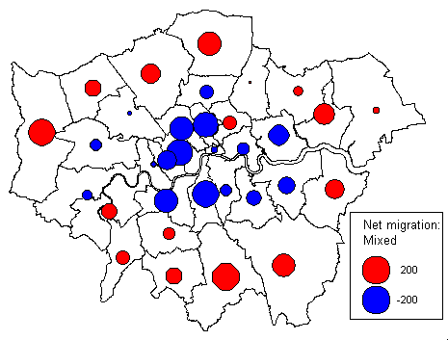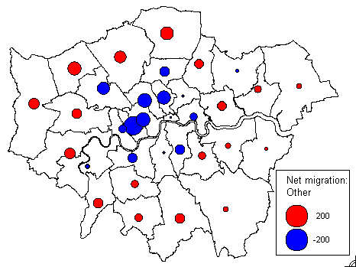

(a) Mixed within London (b) Other within London
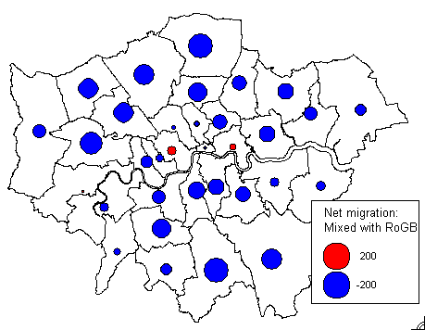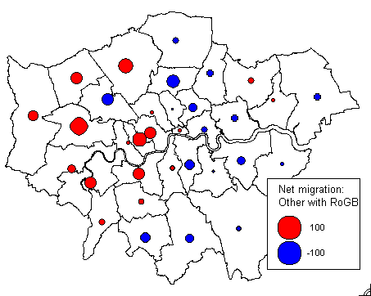
(c) Mixed with rest of GB (d) Other with rest of GB

Figure 21: Net migration balances for mixed and other groups, London boroughs, 2000-01

The correlation between the rates of white net migration and the rates for other ethnic groups are presented in Table 8 and show that it is the mixed group whose geographical patterns of net migration within London most closely approximate those of whites, whereas the other group has a negative correlation with white net migration. The pattern of white net migration with the rest of Britain is most closely correlated with that of the Chinese, but Indian and black net migration has a negative correlation with white net migration, although this is insignificant in the case of the latter.

Table 8: Correlation between white and non-white net migration rates, London boroughs, 2000-01

White  against | Net migration rates within London | Net migration rates with rest of GB
 | r | r
Indian | 0.37363 | -0.41534
Pakistani & OSA | 0.46074 | 0.35487
Chinese | 0.37246 | 0.54549
Black | 0.51569 | -0.09229
Mixed | 0.75615 | 0.48007
Other | -2.61889 | 0.03279

6 Conclusions and further research
This paper has demonstrated how internal migration intensities and patterns varied by ethnic group in Britain the year before the 2001 Census. It has shown that 91 out of every 100 migrants were white, that only the South Asians have the lower migration propensities than whites, that the Chinese and other ethnic groups have the highest migration rates and that the Chinese are the only ethnic group whose rates of inter-district migration are higher than their rates of intra-district migration. Chinese migrants tend to move further distances and the Chinese population has the lowest segregation index, whereas members of the POSA ethnic group tend to move over the shortest distances although they are less segregated at the district level that blacks.

The district pattern of aggregate net migration is dominated by white net outflows from London boroughs and metropolitan districts and white net inflows to areas lower in the urban hierarchy and rural areas as it was a decade earlier. This pattern of net migration is not reflected by minority ethnic groups. Moreover, the efficiency or effectiveness of net inter-district migration tends to be much higher for non-white groups than for whites. The calculations indicate that around 5% of all white migration between districts involves a net redistribution of the population from one district to another whereas the migration efficiency of inter-district migration is more than double for other groups; in other words, the impact of net migration on population redistribution is considerably more important for non-white groups compared with whites.

We have observed that positive or negative net migration balances for non-white groups tend to be concentrated in metropolitan or larger urban areas but that the relationship between the gross in-migration and out-migration components of net migration are much less highly correlated than for whites. The relatively concentrated nature of ethnic populations and ethnic migration in Britain makes comparison across the whole system of spatial units more difficult but our analyses do suggest that areas that have lower than the national white population shares experience net white out-migration, that non-white immigration tends to be concentrated in areas which already have higher non-white population shares and that districts with higher rates of non-white immigration also have higher rates of internal white net out-migration. We do not suggest cause and effect – that white migrants are leaving areas characterised as having higher proportions of non-whites in their populations and higher non-white immigration rates because of intolerance of the ethnic minority populations. This may be one of a number of push factors that include adverse socio-economic conditions. and disillusion with inner city living or it may be that the white population is continuing to be pulled out to more rural surroundings through counterurbanisation processes in a manner characteristic of the last three decades. Unfortunately, we have insufficient knowledge about the motivations for migration of white migrants and moreover, given the racist overtones involved, it is questionable whether survey research on whites leaving cities would divulge their precise motivations for departure. This is an area where further qualitative research would prove valuable.

London has a dominant effect on internal migration in Britain, attracting large numbers of in-migrants but also generating even more out-migrants. We have shown in the latter section of the paper that the pattern of aggregate white net migration for London boroughs can be decomposed so as to expose the process of decentralisation taking place from inner to outer boroughs within the capital, whilst simultaneously, inner boroughs are gaining migrants from the rest of the country and outer boroughs are losing migrants to these areas in net terms. This clear pattern is replicated by certain non-white ethnic groups more than others - for the major groups, there is evidence to show net movement away from ethnic concentrations to other parts of London and to the rest of the country. The deconcentration of the non-white population through migration has been documented previously (Cameron and Field, 2000; Simpson, 2004; Phillips, 2006; Stillwell and Phillips, 2006) and serves to dispel the ‘myth of non-white ethnic group self-segregation’ (Simpson, 2004) despite the range of positive factors such as familiarity, security, family links, shared cultures, traditions and language that encourage residential clustering.

Results of research on internal migration by ethnic group that utilise age group data commissioned from ONS and summarise patterns using an district classification system are reported in Hussain and Stillwell (2008) whilst further work is underway which looks at ethnic migration in London in more detail using wards rather than boroughs as the spatial units of origin or destination.

References

Bailey, N. and Livingston, M (2005) Determinants of individual migration: an analysis of SARs data, SCRSY Working Paper No 3, Scottish Centre for Research on Social Justice, University of Glasgow, Glasgow.

Bains, B. (2005) Patterns of ethnic segregation in London, DMAG Briefing Paper 2005/38, Greater London Council Data Management and Analysis Group, Greater London Council, London.

Cameron, S. and Field, A. (2000) Community, ethnicity and neighbourhood, Housing Studies, 15(6): 827-843.

Champion, A.G. (1996) Internal migration and ethnicity in Britain, in Ratcliffe, P. (ed.) Ethnicity in the 1991 Census. Volume 3: Social geography and Ethnicity in Britain: Geographical Spread, Spatial Concentration and Internal Migration, HMSO, London, pp. 135-173.

Champion, A.G. (2005a) Population movement within the UK, in Chappell, R. (ed.) Focus on People and Migration, Palgrave Macmillan, Basingstoke, pp. 92-114.

Champion, A.G. (2005b) The counterurbanisation cascade in England and Wales since 1991: the evidence of a new migration dataset, BELGEO, 1-2: 85-101.

Champion, A.G., Coombes, M., Raybould, S. and Wymer, C. (2007) Migration and Socio-economic Change, Report for Joseph Rowntree Foundation, The Policy Press in association with JRF, York.

Champion, A.G., Fotheringham, A.S., Rees, P., Boyle, P. and Stillwell, J. (1998) The Determinants of Migration Flows in England: A Review of Existing Data and Evidence, Report for the Department of the Environment, Transport and the Regions, University of Newcastle upon Tyne, Newcastle.

Cordey-Hayes, M. and Gleave, D. (1975) Dynamic models of the interaction between migration and the differential growth of cities, in Baxter, R., Echenique, M. and Oivers, J. (eds.) Urban Development Models, LUBFS Conference Proceedings No. 3, The Construction Press Ltd.

Dennett, A. and Stillwell, J. (2008) Internal migration in Great Britain – a district level analysis using 2001 Census data, Working Paper xx/08, School of Geography, University of Leeds, Leeds

Finney, N. and Simpson, L. (2008) Internal migration and ethnic groups: evidence for Britain from the 2001 Census, Population, Space and Place, 14: 63-83.

Hussain, S. and Stillwell, J. (2008) Internal migration of ethnic groups in England and Wales by age and district type, Working Paper 08/3, School of Geography, University of Leeds, Leeds.

Johnson, R, Poulsen, M. and Forrest, J. (2001) The ethnic geography of EthniCities: the American model and residential concentration in London, Ethnicities, 2: 209-235.

Johnson, R., Forrest, J. and Poulsen, M. (2002) Are there ethnic enclaves/ghettos in English Cities?, Urban Studies, 39(4): 591-618.

Johnson, R., Burgess, S., Wilson, D. and Harris, R. (2006) School and residential segregation: an analysis of variations across England’s Local Education Authorities, Regional Studies, 40: 973-990.
Large, P. and Ghosh, K. (2006) Estimates of the population by ethnic group for areas within England, Population Trends, 124: 8-17.

Lupton, R. and Power, A. (2004) Minority ethnic groups in Britain, CASE-Brookings Census Briefs No. 2, Centre for Analysis of Social Exclusion, LSE, London.

Mackintosh, M. (2005) 2001 Census: The migration patterns of London’s ethnic groups, DMAG Briefing Paper 2005/30, Greater London Council Data Management and Analysis Group, Greater London Council, London.

Mateos, P. (2007) An ontology of ethnicity based upon personal names: with implications for neighbourhood profiling, Unpublished PhD Thesis, University College London, London.

Owen, D. and Green, A. (1992) Migration patterns and trends, in Champion, A. and Fielding, A. (eds.) Migration Processes and Patterns Volume I : Research Progress and Prospects, Belhaven Press, London, pp. 17-40.

Peach, C. (1996a) Ethnicity in the 1991 Census, Volume 2: The Ethnic Minority Populations of Great Britain, Office for National Statistics, The Stationery Office, London.

Peach, C. (1996b) Does Britain have ghettoes?, Transactions, Institute of British Geographers NS, 22: 216-235.

Peloe, A. and Rees, P. (1999) Estimating ethnic change in London, 1981-91, using a variety of census data, International Journal of Population Geography, 5: 179-194.

Phillips, D. (1998) Black minority ethnic concentration, segregation and dispersal in Britain, Urban Studies, 35(10): 1681-170.

Phillips, D. (2006) Parallel lives? Challenging discourses of British Muslim self-segregation, Environment and Planning D: Society and Space, 24(1): 25-40.

Phillips, D., Stillwell and J. Burrage A. (2004) Geographies of ethnicity and religion in Leeds, in Stillwell, J. and Unsworth, R. (eds.) Twenty-first Century Leeds: Contemporary Geographies of a Regional City, Leeds University Press, Leeds, pp. 49-74.

Rankin, J. and Bhopal, R. (1999) Current census categories are not a good match for identity, British Medical Journal, 318(7199): 1696.

Ratcliffe, P. (ed.) (1996) Ethnicity in the 1991 Census, Volume 3: Social Geography and Ethnicity in Britain: Geographical Spread, Spatial Concentration and Internal Migration, Office for National Statistics, The Stationery Office, London.

Rees, P. and Butt, F. (2004) Ethnic change and diversity in England, 1981–2001, Area, 36(2): 174-186.

Rees, P., Phillips, D. and Medway, D. (1995) The socioeconomic geography of ethnic groups in two northern British cities, Environment and Planning A, 27: 557- 591.

Rees, P., Thomas, F. and Duke-Williams, O. (2002) Migration data from the census, in Rees, P., Martin, D. and Williamson, P. (eds.) The Census Data System, Wiley, Chichester, pp. 245-267.

Robinson, V. (1992) Move on up: the mobility of Britain’s Afro-Caribbean and Asian populations, in Stillwell, J., Rees, P. and Boden, P. (eds.) Migration Processes and patterns Volume 2 Population Redistribution in the United Kingdom, Belhaven Press, London, pp. 271-291.

Robinson, V. (1993) Race, gender and internal migration within England and Wales, Environment and Planning A, 25: 1453-1465.

Rogers, A. (1978) Demometrics of migration and settlement, in Batey, P.W.J. (ed.) London Papers in Regional Science 8 Theory and Method in Urban and Regional Analysis, Pion, London, pp. 1-30.

Rogers, A. and Castro, L.J. (1981) Model migration schedules, RR-91-30, International Institute for Applied Systems Analysis, Laxenburg.

Simpson, L. (2004) Statistics of racial segregation: measures, evidence and policy, Urban Studies, 41(3): 661-681.

Simpson, L. (2005a) Population dynamics in Oldham and Rochdale: the nature of dispersal, paper presented at the British Society of Population Studies Annual Conference, University of Kent, Canterbury.

Simpson, L. (2005b) Measuring residential segregation. Summary of presentation with national tables, http://www.ccsr.ac.uk/research/migseg.htm. Accessed 1 February 2008.

Stillwell, J. (2006) Providing access to census-based interaction data in the UK: that’s WICID, The Journal of Systemics, Cybernetics and Informatics, 4(4): 63-68.

Stillwell, J. and Duke-Williams, O. (2003) A new web-based interface to GB Census of Population origin-destination statistics, Environment and Planning A, 35(1): 113-132.

Stillwell, J.C.H. and Duke-Williams, O. (2005) Ethnic distribution, immigration and internal migration in Britain: what evidence of linkage at the district scale?, Paper presented at the British Society for Population Studies Annual Conference, University of Kent at Canterbury, 12-14 September.

Stillwell, J. and Duke-Williams, O. (2006) Understanding the 2001 Census interaction data: the impact of small cell adjustment and problems of comparison with 1991, Journal of the Royal Statistical Society Series A, 170(2): 1-21.

Stillwell, J. and Phillips, D. (2007) Diversity and change: understanding the ethnic geographies of Leeds, Journal of Ethnic and Migration Studies, 32(7): 1131-1152.

Scott, A., Pearce, D. and Goldblatt, P. (2001) The sizes and characteristics of the minority ethnic populations of Great Britain – latest estimates, Population Trends, 105: 6-15

Vickers, D., Rees, P. and Birkin, M. (2003) A new classification of UK local authorities using 2001 Census key statistics, Working Paper, 03/5, School of Geography, University of Leeds, Leeds.

Warnes, A. (1992) Migration and the life course, in Champion, A. and Fielding, A. (eds.) Migration Processes and Patterns, Volume 1, Research Progress and Prospects, Belhaven, London, pp. 175-187.

